(Approx. 863 words)

Stellarium – A Home Planetarium
By Dick Maybach, Member, Brookdale Computer User Group, NJ
www.bcug.com
n2nd (at) att.net

This free software for Windows, Linux, and OS X (http://stellarium.org/) turns your PC or Raspberry Pi into a planetarium to display the stars in the sky, the constellations, and individual and groups of stellar objects. There is a Web-based version you can access with a browser (at http://stellarium-web.org/), and variants are available for cell phones (usually for a small cost). Available on the home page is a 355-page user guide, and you should read this if you want to do more than take a casual look at the night sky.

Features
- Over 600,000 stars from the Hipparcos Catalogue and the Tycho-2 Catalogue, with extra catalogues available containing more than 210 million stars
- Illustrations of the constellations, from the Western and other cultures
- Images of nebulae (full Messier catalog)
- Realistic Milky Way
- Realistic atmosphere, sunrise and sunset
- Planets of the solar system and their major moons
- Ability to display stars and other celestial objects as seen from reference points other than the Earth

Visualizations
- Equatorial and azimuthal grids
- Star twinkling
- Simulations of meteors and eclipses
- Deep sky objects

If you are connected to the Internet, Stellarium will configure itself on startup by loading your location, although you can fine tune this. It starts in full-screen mode, which you can turn off from the menu bar, visible when you move the cursor to the bottom of the screen. A second menu bar appears when you move the cursor to the left edge of the screen (both are shown in Figure 1). Stellarium shows the sky for a given time, which by default is the current time. This was 7:30 pm. on a summer day for Figure 1, and of course, the stars weren’t visible, because our atmosphere scatters sunlight which overpowers light from the stars. Stellarium allows you to turn off this effect so you can see the stars during the day. (The sun still appears as a very bright star.) The program also allows you to remove the ground to view stars below the horizon.

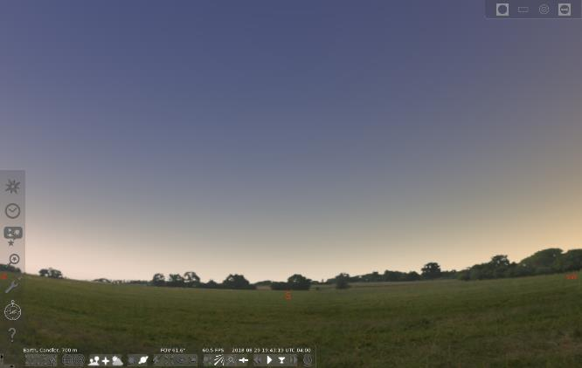
Figure 1. Stellarium Day View.

Advancing the time past sunset, results in the more satisfactory view of Figure 2, where the field of view has also been increased to show more of the sky. By default, only the major objects are labeled. (The two objects labeled “Aquariids” are meteor showers.)

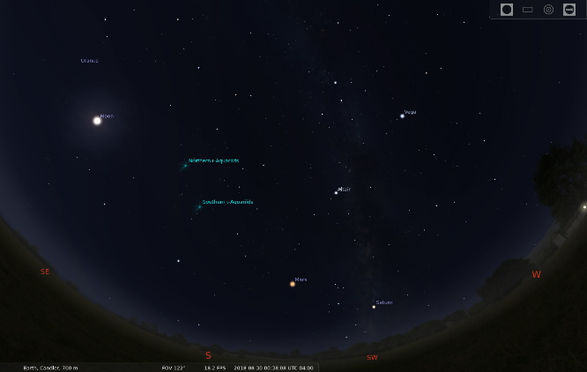
Figure 2. Stellarium Night View

You move around the sky with the mouse and zoom with the mouse wheel (or the Page-up and Page-down keys). Because your PC screen is flat and relatively small, you will probably display only a portion of the sky. (Stellarium’s default is to show approximately what appears in your normal field of view.) However, you can zoom back to see everything above the horizon, as shown in Figure 3.

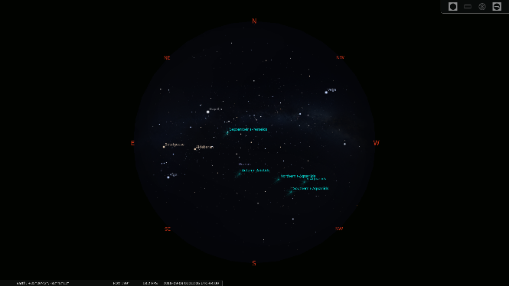
Figure 3. Full Sky View.

You can add the constellations as lines connecting their starts as shown in Figure 4, and you can also see their artwork as in Figure 5. The constellations and artwork shown are those used in the western world, which are the defaults. The program can instead display the constellations of many other cultures.

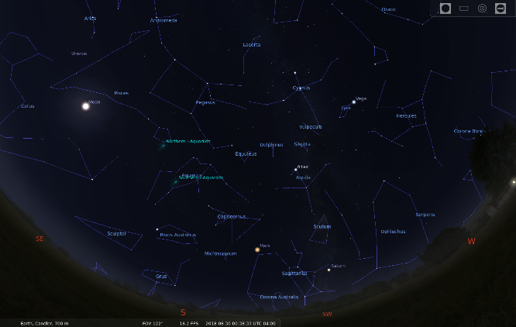
Figure 4. Constellations.

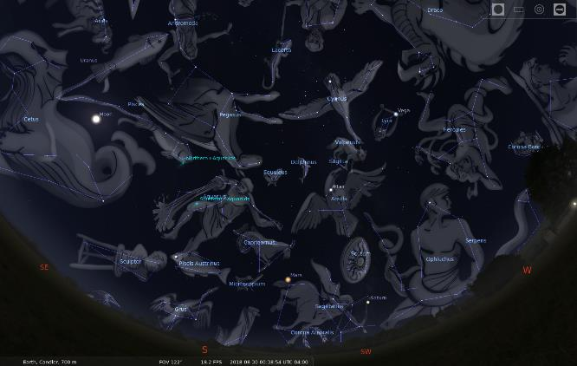
Figure 5. Constellation Art (Western Traditional).

Selecting an object displays information about it; Figure 6 shown this for Polaris. Most users will configure the program to show fewer data, as much of what is shown here will interest only astronomy enthusiasts.

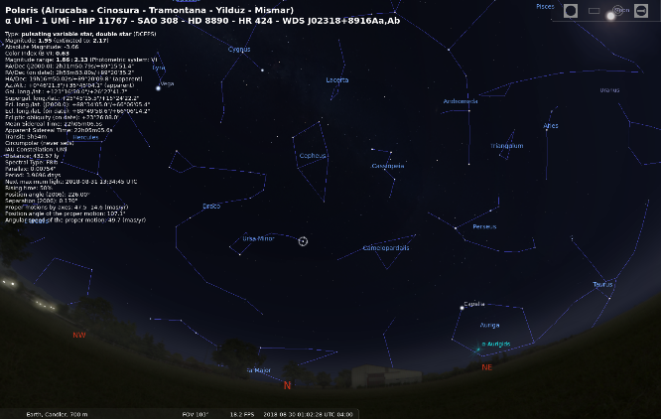
Figure 6. Information Displayed About Polaris.

You can zoom in to view individual objects, such a Saturn in Figure 7. By default, Stellarium shows the sky in real time, and at high magnifications individual objects will rapidly move off the screen, but you can correct this by stopping its clock.

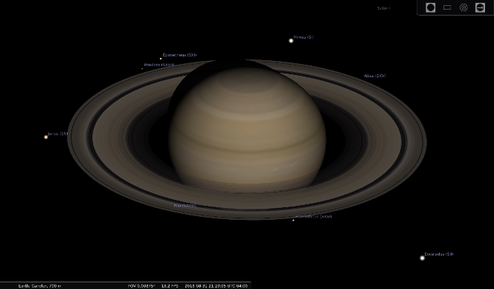
Figure 7. Saturn.

If you have Stellarium on a laptop or other mobile device, you can use it outside to help you identify features in the actual sky. In this case, you’ll want to use Night Mode, which displays everything in red to preserve your night vision; see Figure 8.

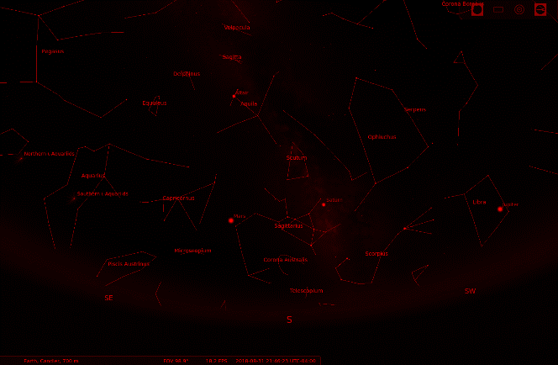
Figure 8. Night Mode.

In addition to the visible stars and planets, Stellarium can also show artificial satellites and deep sky objects (DSOs). The term is used for the most part by amateur astronomers to denote faint objects such as star clusters, nebulae, and galaxies. It can also show exoplanets (planets that orbit other stars than our sun). As Figure 9 shows, if you display both satellites and deep sky objects, the screen becomes quite cluttered. Especially, since the satellites except those in synchronous orbits are in rapid motion. (In the figure, the synchronous satellites appear in an arc about one-third down from the top.)

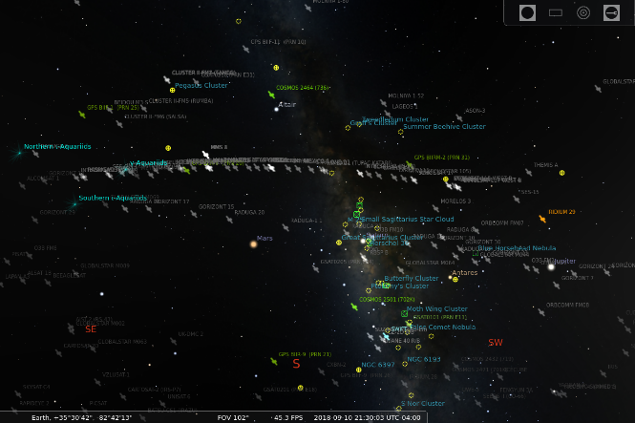
Figure 9. Satellites and Deep Sky Objects.

Folks now know far less about our night sky than in the past, when nights were darker and the stars more visible, and we also tend to spend our nights indoors. Most of us can identify only the big and little dipper constellations. Stellarium offers you a way to expand your knowledge without even leaving your chair, although stepping outside on a clear night to look at the actual sky is always rewarding.

